Name | Vineet Parmar
UID no. | 2021300092
Experiment No. | 7

AIM: | Implement various text processing problems.
Program 1
PROBLEM STATEMENT : | Write a program to count the number of vowels, consonants, total characters and words in the given string.
ALGORITHM: | - START  - Define integer function vowel with a character c as parameter  - If(c is equal to any of vowels)  Return 1  Else  Return 0  - Define integer function consonant with a character c as parameter  - If(vowels(c)=0 and ((c>=65 and c<=90)or(c>=97 and c<=122))  Return 1  Else  Return 0  - Define integer function words with a character array str[] as parameter  - Count =0, i=0  - If (str[i] is equal to ‘ ‘)  count++  - I++  - Return count+1  - Define main function  - Input string str  - I=0,vcount=0,ccount=0  - If(vowels(str[i])=1)  vcount++  Else(consonants(str[i]=1))  ccount++  - Repeat till str[i]!=0  - Print vcount  - Print ccount  - Print vcount+ccount  - Print words(str)  - Print i  - STOP
PROGRAM: | #include<stdio.h>  int vowels(char c)  {  if(c=='A' || c=='E' || c=='I' || c=='O' || c=='U' || c=='a' || c=='e' || c=='i' || c=='o' || c=='u')  return 1;  else  return 0;  }  int consonant(char c)  {  if(vowels(c)==0 && ((c>=65 && c<=90) || (c>=97 && c<=122)))  return 1;  else  return 0;  }  int words(char str[])  {  int count=0;  for(int i=0;i<str[i]!=0;i++)  if(str[i]==' ')  count++;  return count+1;  }  int main()  {  char str[100];  int vcount=0, ccount=0;  printf("Enter a string : ");  scanf("%[^\n]",str);  for(int i=0;str[i]!='\0';i++)  {  if(vowels(str[i])==1)  vcount++;  else if(consonant(str[i])==1)  ccount++;  }  int word=words(str);  printf("No of vowels : %d\n",vcount);  printf("No of consonants : %d\n",ccount);  printf("No of characters : %d\n",vcount+ccount);  printf("Length of the string : %d\n",i);  printf("No of words : %d\n",word);  return 0;  }
RESULT: 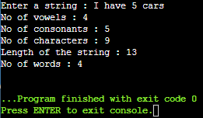
Program 2
PROBLEM STATEMENT : | Write a Menu driven Program to:  - copy one string to another one by one character  - Find the string length  - compare two strings  - reverse the string  - Concatenate one string to another string  - lower case to upper
ALGORITHM: | 1. START  2. Define void function copystr with two character arrays str[] and strn[] as parameters.  3. Int i=0  4. strn[i]=str[i]  5. i++  6. Repeat 5 and 6 untill str[i]!=0  7. strn[i]=0  8. Define integer function length with character array str[] as parameters  9. i=0  10. i++  11. Repeat 10 till str[i]!=0  12. Return i  13. Define void function compare with 3 character array str1[], str2[] and str[] as parameters  14. int i=0, count=0  15. if(str1[i]<str2[i])  copystr(str2,str)  count=1  Go to step  else if(str1[i]>str2[i])  copystr(str1,str)  count=1  Go to step  16. i++  17. Repeat 15 and 16 till str1[i] =0 or str2[i]=0  18. if count=0  copystr(str1,str)  19. Define void function reverse with 2 character arrays str[] and strn[] as  parameters.  20. Int length = length(str)  21. i=0  22. strn[i] = str[len-i-1]  23. i++  24. Repeat 22 and 23 till i<len  25. str[len]=0  26. Define void function concatenate with 3 character arrays str1[], str2[] and  str[] as parameters.  27. Len = length(str1), i=0  28. str[i]=str1[i]  29. i++  30. Repeat 28 and 29 till str[i]!=0  31. str[i]=str2[i-len]  32. i++  33. Repeat 31 and 32 till str2[i-len]!=0  34. str[i]=0  35. Define void function convert with two character arrays str[] and strn[] as  parameters.  36. Int i=0  37. if(str[i]>=97 and str[i]<=122)  strn[i] = str[i]-32  else  strn[i] = str[i]  38. i++  39. Repeat 37 and 38 till str[i] !=0  40. Define main function  41. Input two strings str1[] and str2[]  42. int option  43. Input option  44. If (option ==1)  copystr(str1,strn1)  copystr(str2,strn2)  print str1 and str2  else if (option == 2)  print length(str1) and length(str2)  else if (option == 3)  compare(str1,str2,strn)  print strn  else if (option == 4)  reverse(str1,strn1)  reverse(str2,strn2)  print strn1 and strn2  else if (option == 5)  concatenate(str1,str2,strn)  print strn  else if (option == 6)  convert(str1,strn1)  convert(str2,strn2)  print strn1 and strn2  45. Return 0  46. STOP
PROGRAM: | #include<stdio.h>  void copystr(char str[], char strn[])  {  int i;  for(i=0;str[i]!='\0';i++)  strn[i]=str[i];  strn[i]='\0';  }  int length(char str[])  {  int i;  for(i=0;str[i]!='\0';i++);  return i;  }  void compare(char str1[], char str2[], char str[])  {  int count=0;  for(int i=0;(str1[i]!='\0'|| str2[i]!='\0');i++)  {  if(str1[i]<str2[i])  {  copystr(str2,str);  count=1;  break;  }  else if(str1[i]>str2[i])  {  copystr(str1,str);  count=1;  break;  }  }  if(count==0)  {  copystr(str1,str);  }  }  void reverse(char str[],char strn[])  {  int len = length(str);  for(int i=0;i<len;i++)  {  strn[i]=str[len-i-1];  }  strn[len]='\0';  }  void concatenate(char str1[], char str2[],char str[])  {  int len= length(str1);  int i;  for(i=0;str1[i]!='\0';i++)  str[i]=str1[i];  for(i=i;str2[i-len]!='\0';i++)  str[i]=str2[i-len];  str[i]='\0';  }  void convert(char str[],char strn[])  {  int i;  for(i=0;str[i]!='\0';i++)  {  if(str[i] >= 97 && str[i] <= 122)  strn[i] = str[i] - 32;  else  strn[i] = str[i];  }  strn[i]='\0';  }  int main()  {  int trash;  char str1[100], str2[100],strn1[100],strn2[100];  printf("Enter string 1: ");  scanf("%[^\n]",str1);  printf("Enter string 2: ");  scanf(" %[^\n]",str2);  int option;  do  {  printf("WELCOME\n");  printf("Choose one of the following options\n");  printf("1.Copy one string to another\n");  printf("2.Find string length\n");  printf("3.Compare the two strings\n");  printf("4.Reverse the two strings\n");  printf("5.Concatenate the two strings\n");  printf("6.Lower case to upper case\n");  printf("7.Exit\n");  scanf("%d",&option);  switch(option)  {  case 1:  {  copystr(str1,strn1);  copystr(str2,strn2);  printf("%s\n",strn1);  printf("%s\n\n",strn2);  break;  }  case 2:  {  printf("Length of string 1 is: %d\n",length(str1));  printf("Length of string 2 is: %d\n\n",length(str2));  break;  }  case 3:  {  compare(str1,str2,strn1);  printf("The greater string is: %s\n\n",strn1);  break;  }  case 4:  {  reverse(str1,strn1);  reverse(str2,strn2);  printf("%s\n",strn1);  printf("%s\n\n",strn2);  break;  }  case 5:  {  concatenate(str1,str2,strn1);  printf("%s\n\n",strn1);  break;  }  case 6:  {  convert(str1,strn1);  convert(str2,strn2);  printf("%s\n",strn1);  printf("%s\n\n",strn2);  break;  }  case 7:  break;  default:  {  printf("Invalid Choice. Pls Enter again:\n ");  break;  }  }  }while(option!=7);  return 0;  }
RESULT: 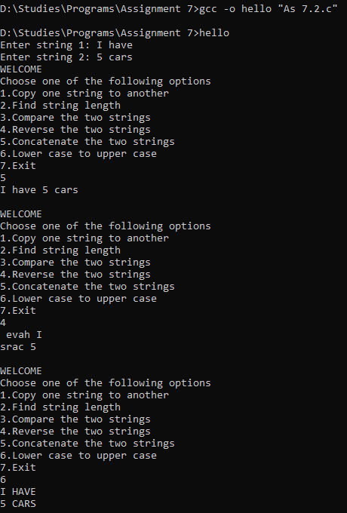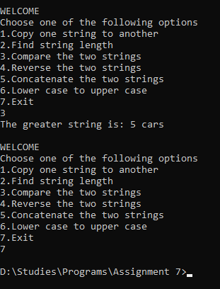
Program 3
PROBLEM STATEMENT: | Write a program to delete all repeated words in string. Input: welcome to C programming class, welcome again to C class Output: welcome to C programming class, again
ALGORITHM: | - START  - Define integer function compare with two character arrays str1[] and str2[] as parameters  - Count = 0, I=0  - If (str1[i]>str2[i] or str1[i]<str2[i])  count = 1  Go to step 7  - i++  - Repeat 4 and 5 till str1[i] = 0 or str2[i] =0  - Return count  - Define void function removed with a character array as parameters  - char mat[100][100], words[100]  - int i=0,j=0,k=0,l=0  - If (str[i]==32)  mat[k][j]=0  k++  j=0  Else  mat[k][j]=str[i]  j++  - i++  - Repeat 11 and 12 till str[i]!=0  - mat[k][j]=0  j=0  i=0  - temp=0  l=1  - If(mat[i][j]==0 or l==1)  Check if (compare(mat[i],mat[l])==0)  mat[i][j] = 0  temp++  - l++  - Repeat 16 and 17 till l<k+1\  - .i++  - Repeat 15,16,17,18 and 19 till i<k  - i=0  j=0  - Is mat[i][j]!=0?  Print mat[i]  - i++  - Repeat 22 and 23 till i<k+1  - STOP
FLOWCHART: | 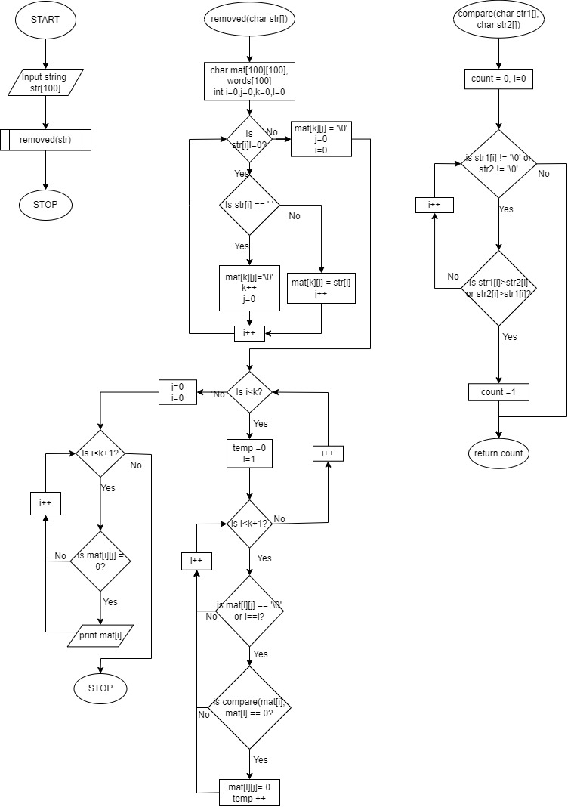
PROGRAM: | #include<stdio.h>  int compare(char str1[100],char str2[100])  {  int count=0;  for(int i=0;(str1[i]!='\0' || str2[i]!='\0');i++)  {  if((str1[i]>str2[i]) || (str1[i]<str2[i]))  {  count=1;  break;  }  }  return count;  }  void removed(char str[100])  {  char mat[100][100], words[100];  int i=0,j=0,k=0,l=0;  for(i=0;str[i]!='\0';i++)  {  if(str[i]==' ')  {  mat[k][j] = '\0';  k++;  j=0;  }  else  {  mat[k][j] = str[i];  j++;  }  }  mat[k][j]='\0';  j=0;  for(i=0;i<k;i++)  {  int temp=0;  for(l=1;l<k + 1;l++)  {  if(mat[l][j] == '\0' || l == i)  {  continue;  }  if(compare(mat[i],mat[l])==0)  {  mat[l][j] = '\0';  temp++;  }  }  }  j=0;  for(i=0;i<k + 1;i++)  {  if(mat[i][j] == '\0')  continue;  else  printf("%s ",mat[i]);  }  }  int main()  {  char str[100];  printf("Enter a string: ");  scanf("%[^\n]",str);  removed(str);  return 0;  }
RESULT: 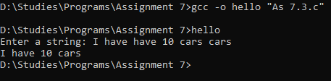
CONCLUSION: | In this experiment, we learned about the basics of strings. We got to know how to input a string in different ways. We also learned about the different operations that can be performed on a string such as concatenation, reversing, etc.

